**WEEK 7**

**9. ReactJS-HOL**

**STEP 1:** To create a new React app, Install Nodejs and Npm from the following link:

<https://nodejs.org/en/download/>

**STEP 2:** Install Create-react-app by running the following command in the command prompt:



**STEP 3:** To create a React Application with the name of “cricketapp”, type the following command:

C:>npx create-react-app cricketapp

**STEP 4:** Once the App is created, navigate into the folder of cricketapp by typing the following command:

C:>cd cricketapp

**STEP 5:** Create two files under src folder

ListOfPlayers.js

IndianPlayers.js

**CODE:**

**ListOfPlayers.js**

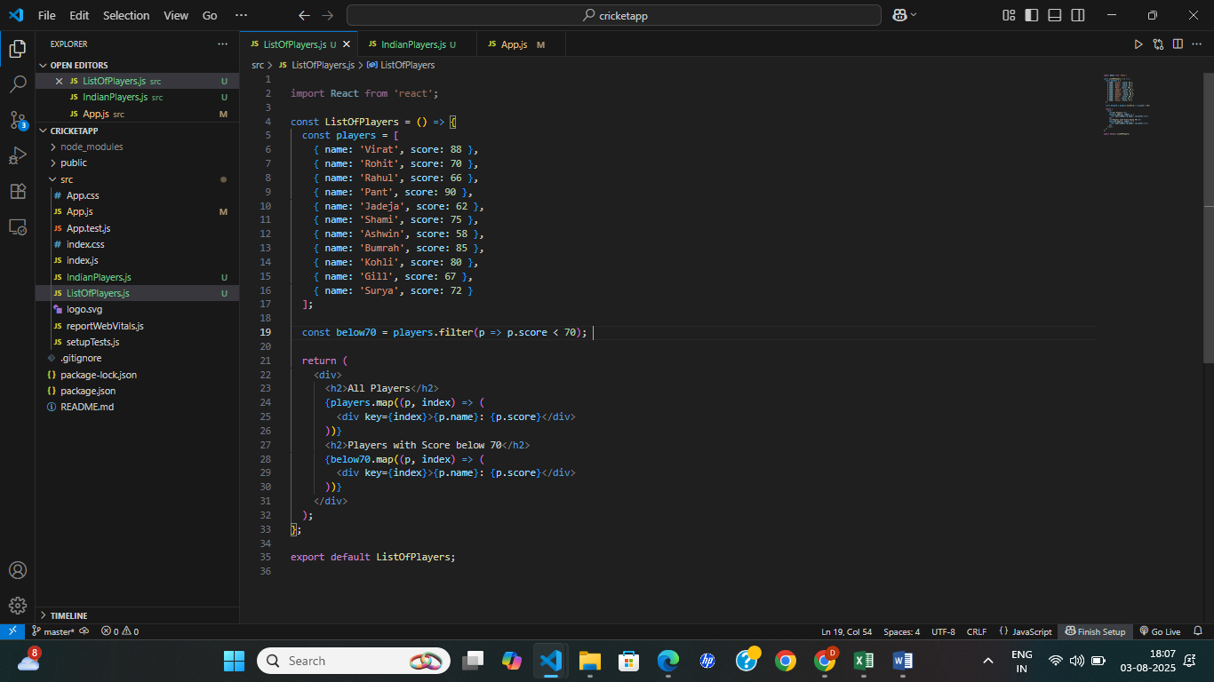

**IndianPlayers.js**

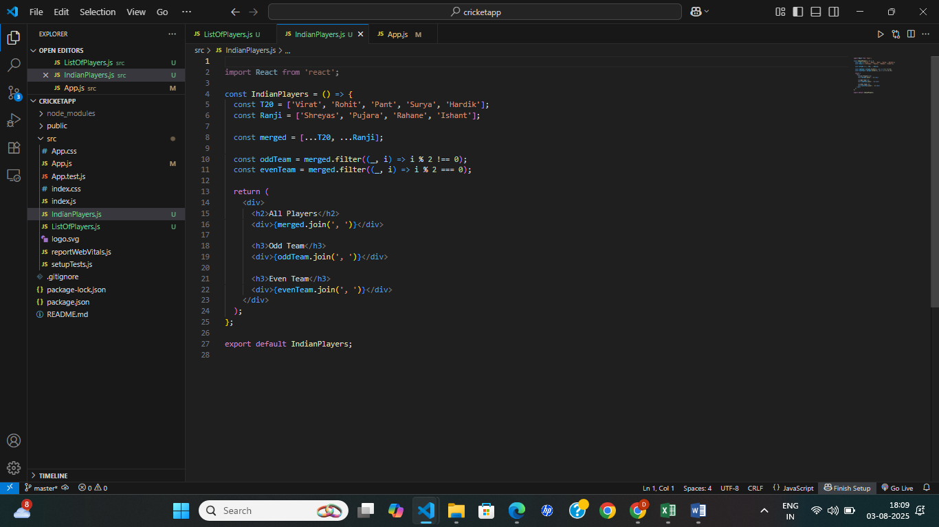

**App.js**

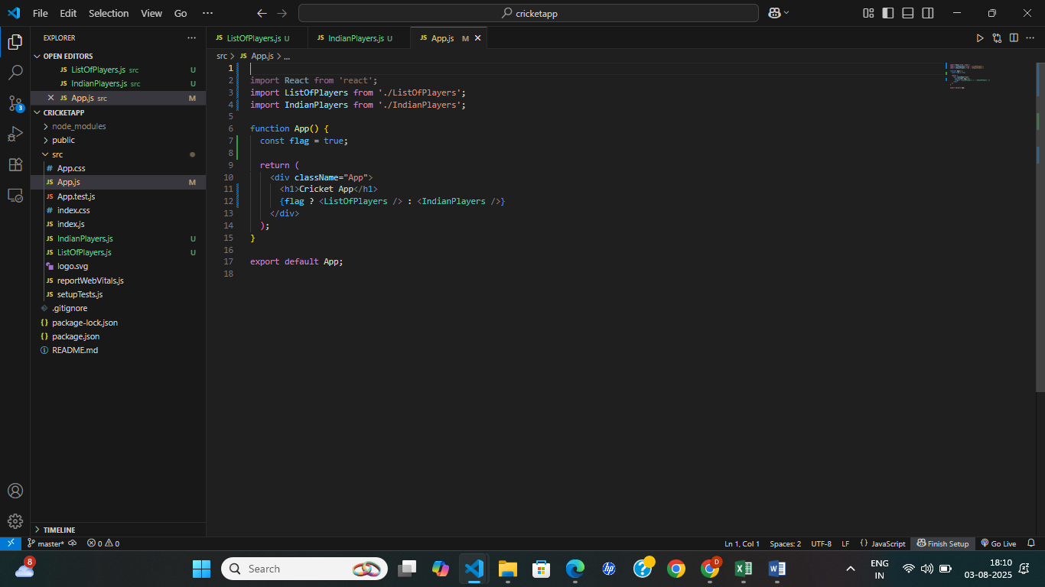

**OUTPUT:**

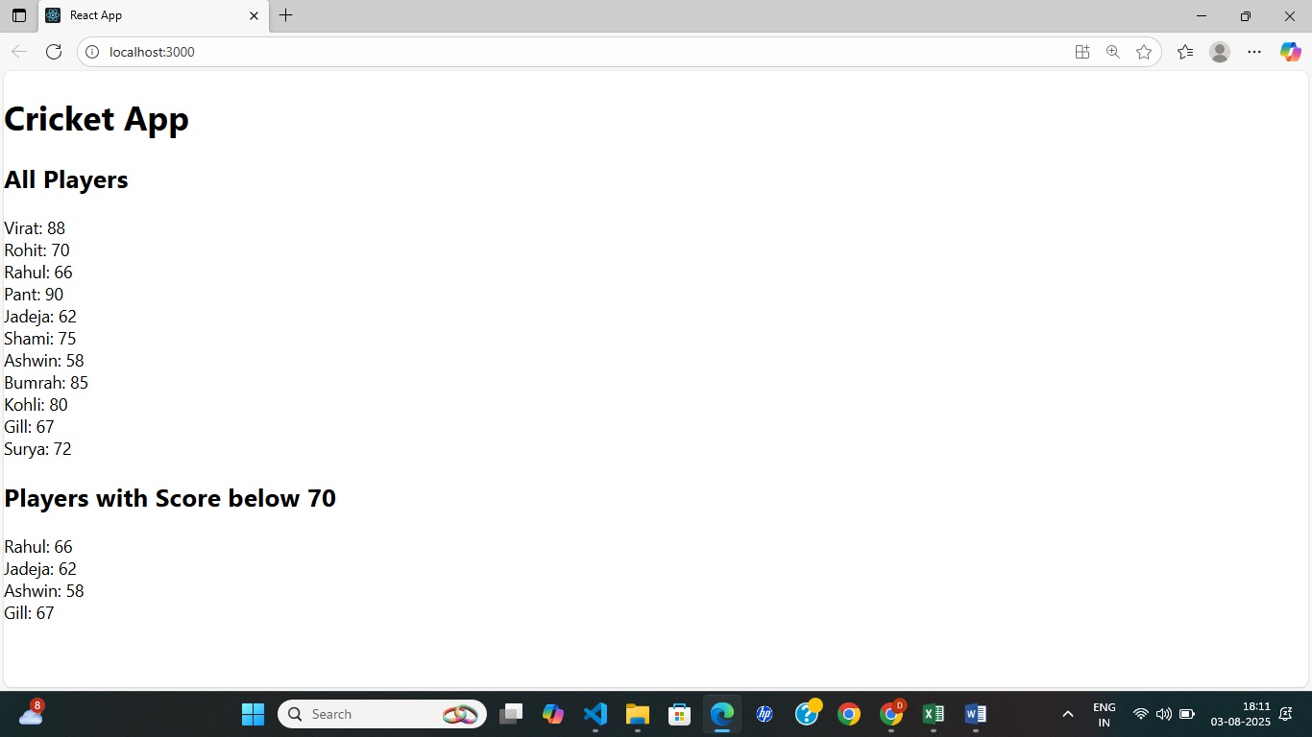

**10. ReactJS-HOL**

**STEP 1:** To create a new React app, Install Nodejs and Npm from the following link:

<https://nodejs.org/en/download/>

**STEP 2:** Install Create-react-app by running the following command in the command prompt:



**STEP 3:** To create a React Application with the name of “officespacerentalapp”, type the following command:

C:>npx create-react-app officespacerentalapp

**STEP 4:** Once the App is created, navigate into the folder of officespacerentalapp by typing the following command:

C:>cd officespacerentalapp

CODE:

App.js

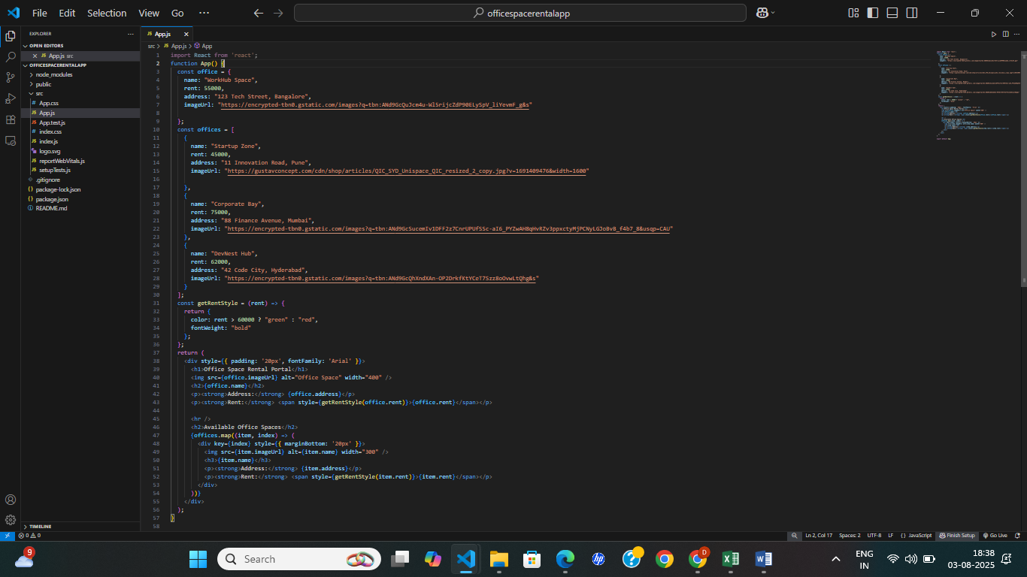

OUTPUT:

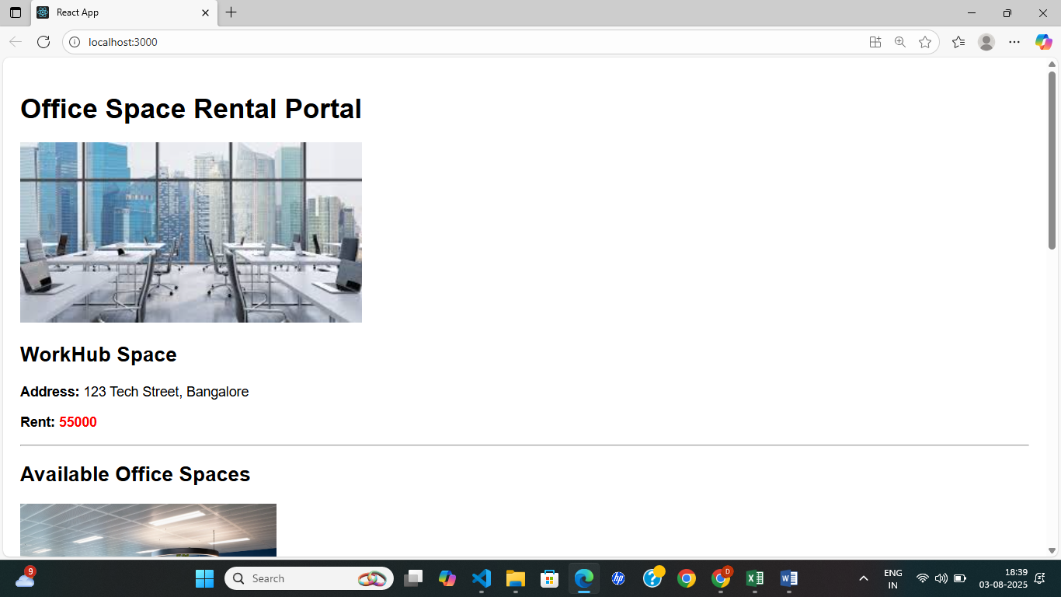

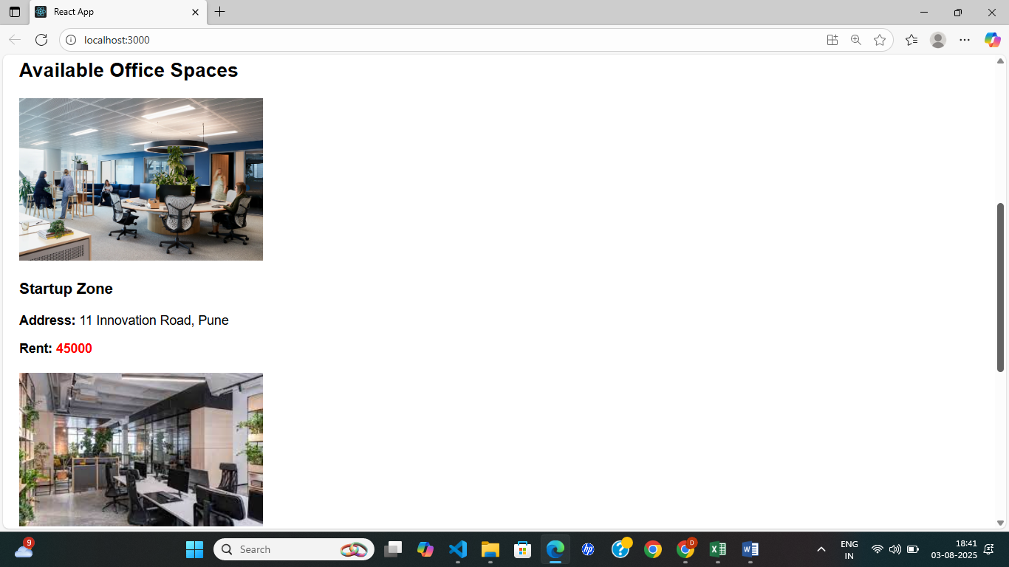

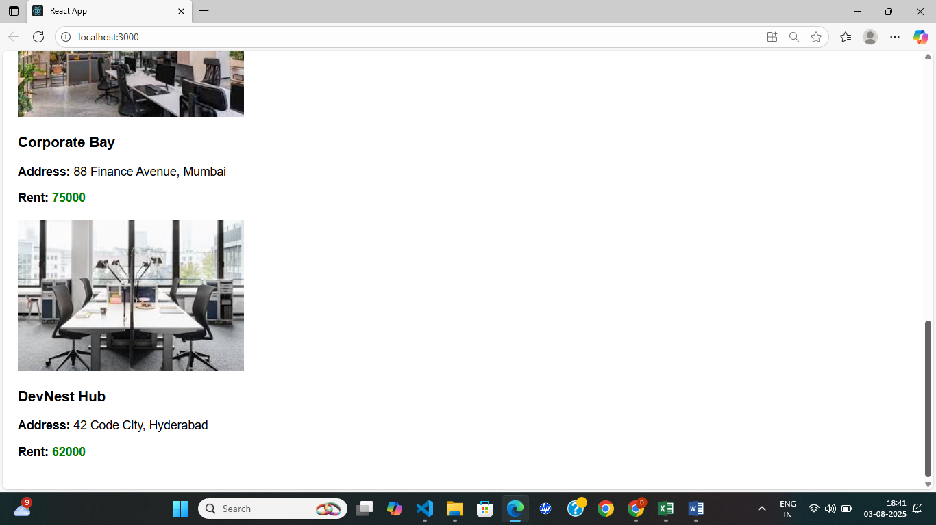

**11. ReactJS-HOL**

**STEP 1:** To create a new React app, Install Nodejs and Npm from the following link:

<https://nodejs.org/en/download/>

**STEP 2:** Install Create-react-app by running the following command in the command prompt:



**STEP 3:** To create a React Application with the name of “eventexamplesapp”, type the following command:

C:>npx create-react-app eventexamplesapp

**STEP 4:** Once the App is created, navigate into the folder of eventexamplesapp by typing the following command:

C:>cd eventexamplesapp

STEP 5: Create a new file under src folder

CurrencyConvertor.js

CODE:

CurrencyConvertor.js

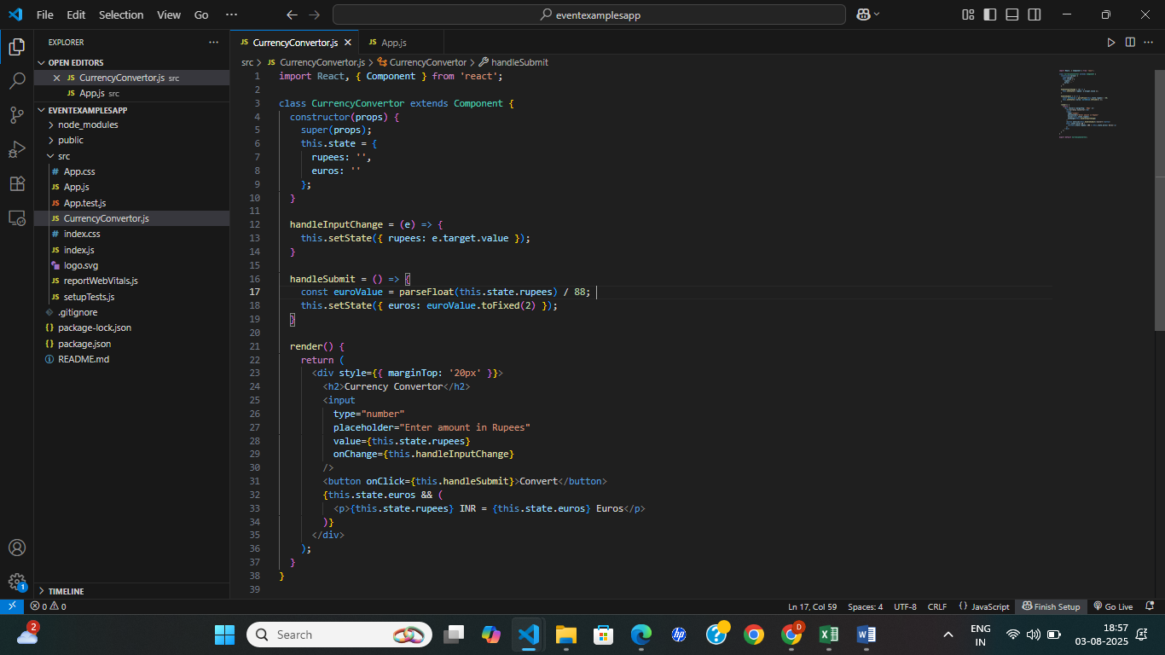

App.js:

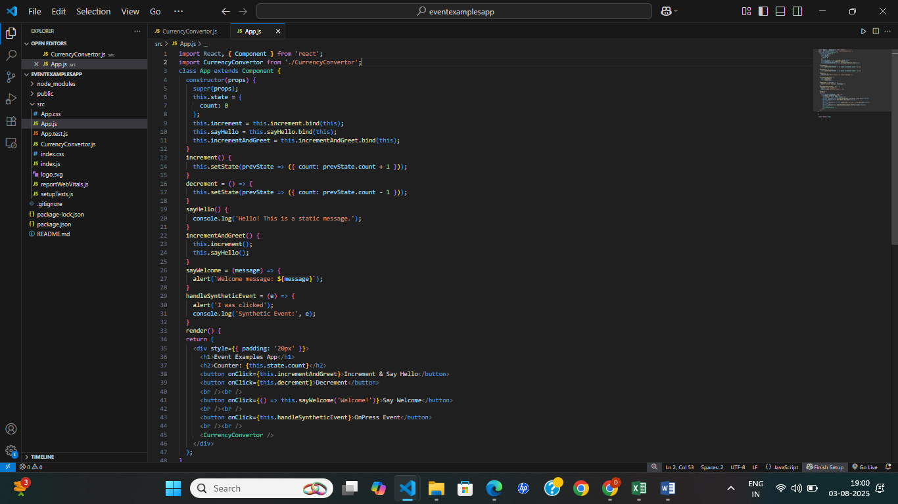

OUTPUT:

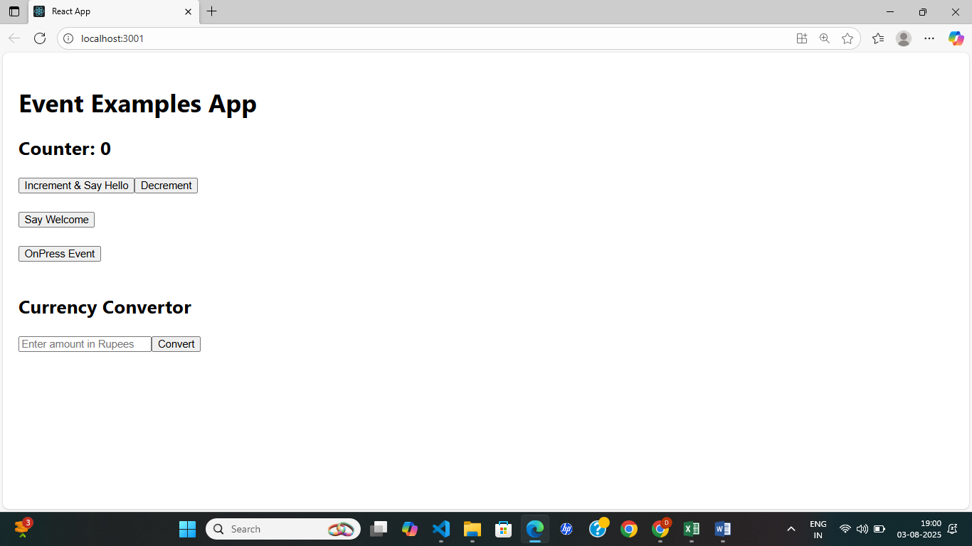

Increment and say welcome

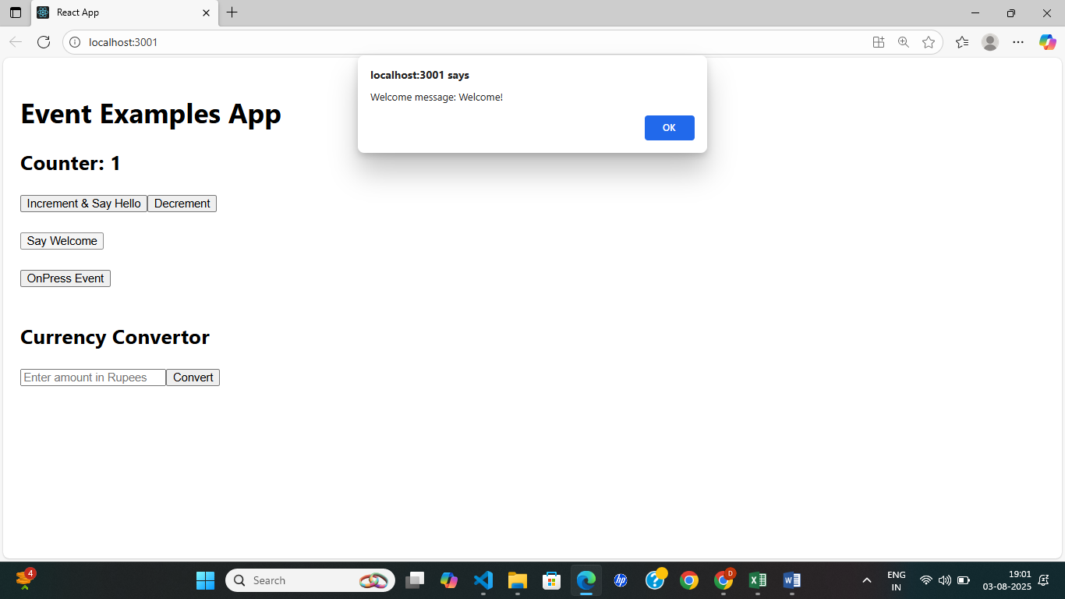

Decrement and onPressEvent

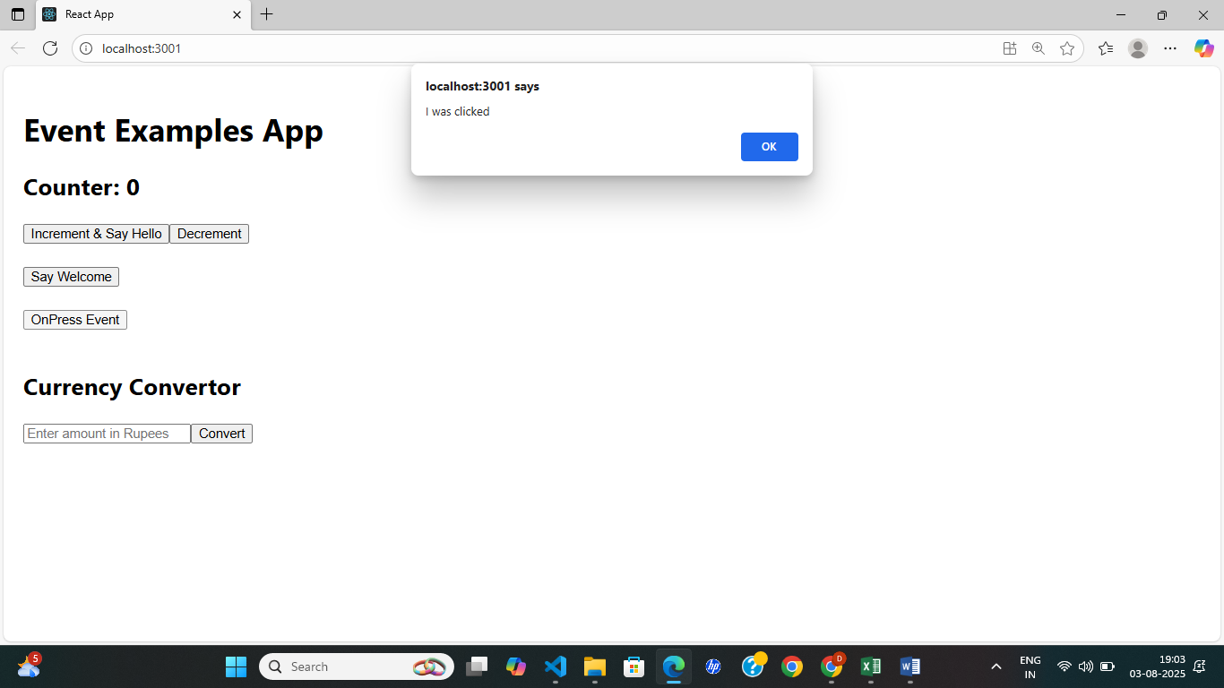

CurrencyConverter:

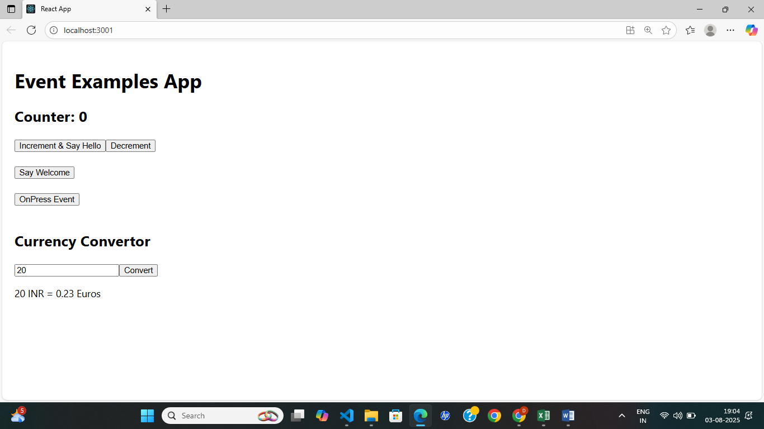

**12. ReactJS-HOL**

**STEP 1:** To create a new React app, Install Nodejs and Npm from the following link:

<https://nodejs.org/en/download/>

**STEP 2:** Install Create-react-app by running the following command in the command prompt:



**STEP 3:** To create a React Application with the name of “ticketbookingapp”, type the following command:

C:>npx create-react-app ticketbookingapp

**STEP 4:** Once the App is created, navigate into the folder of ticketbookingapp by typing the following command:

C:>cd ticketbookingapp

STEP 5: Create a new file under src folder

GuestPage.js

UserPage.js

CODE:

GuestPage.js

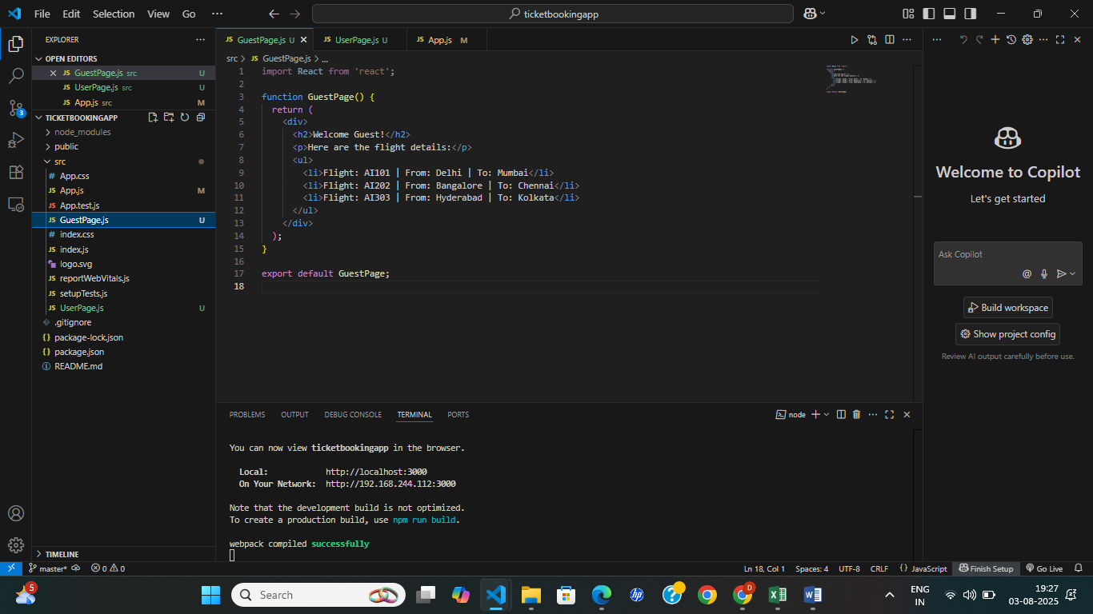

UserPage.js

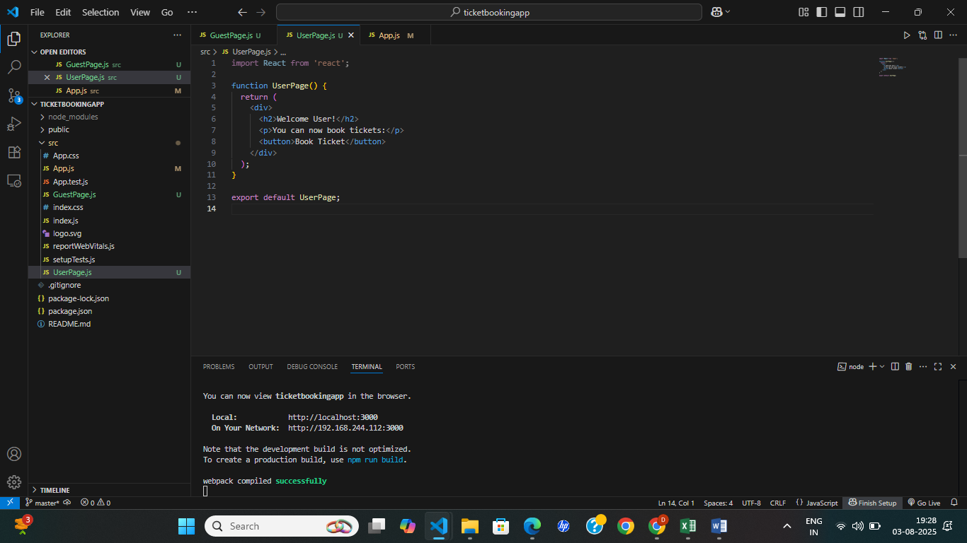

App.js:

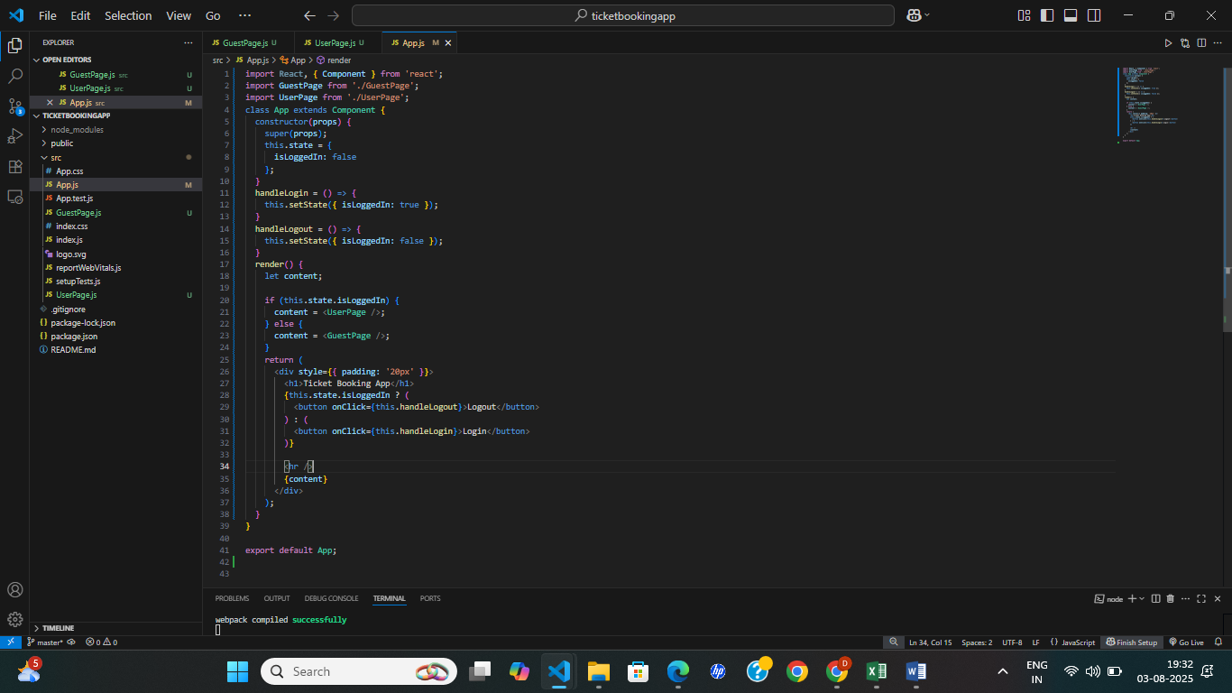

OUTPUT:

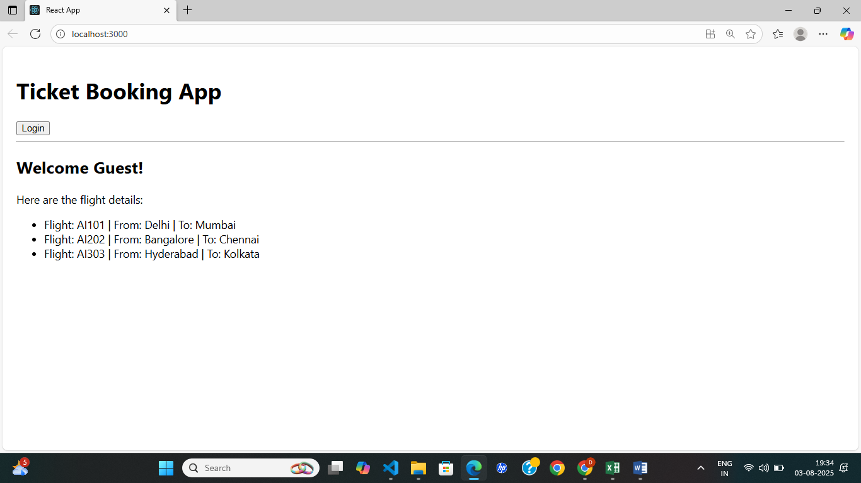

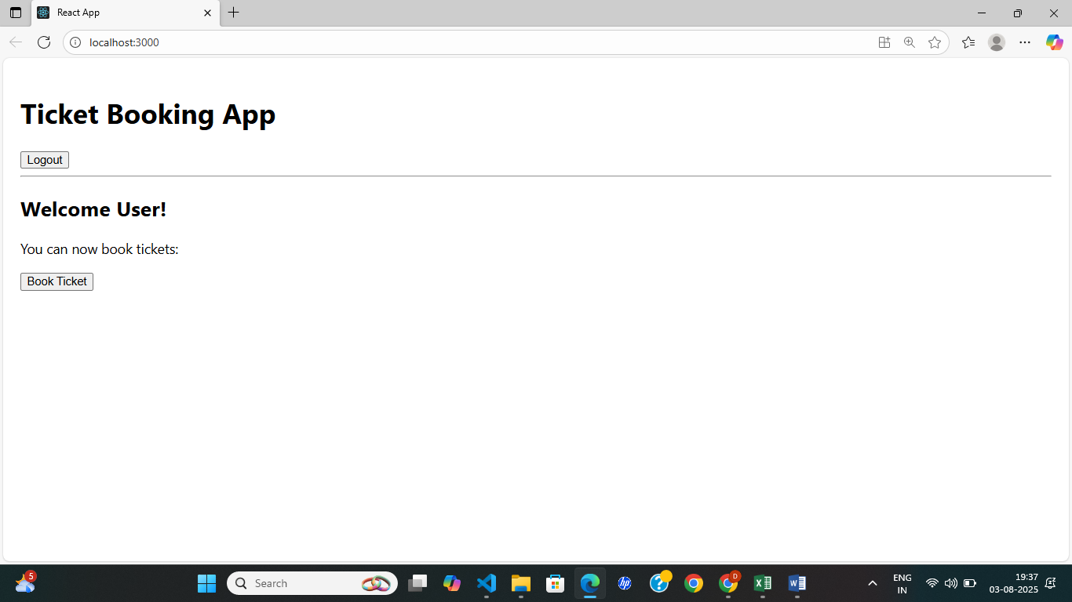

**13. ReactJS-HOL**

**STEP 1:** To create a new React app, Install Nodejs and Npm from the following link:

<https://nodejs.org/en/download/>

**STEP 2:** Install Create-react-app by running the following command in the command prompt:



**STEP 3:** To create a React Application with the name of “bloggerapp”, type the following command:

C:>npx create-react-app bloggerapp

**STEP 4:** Once the App is created, navigate into the folder of bloggerapp by typing the following command:

C:>cd bloggerapp

STEP 5: Create a new file under src folder

BookDetails.js

BlogDetails.js

CourseDetails.js

CODE:

BookDetails.js

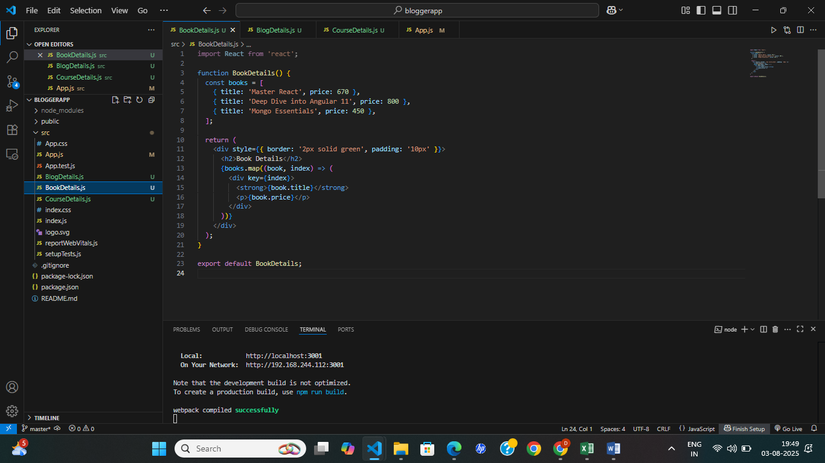

BlogDetails.js

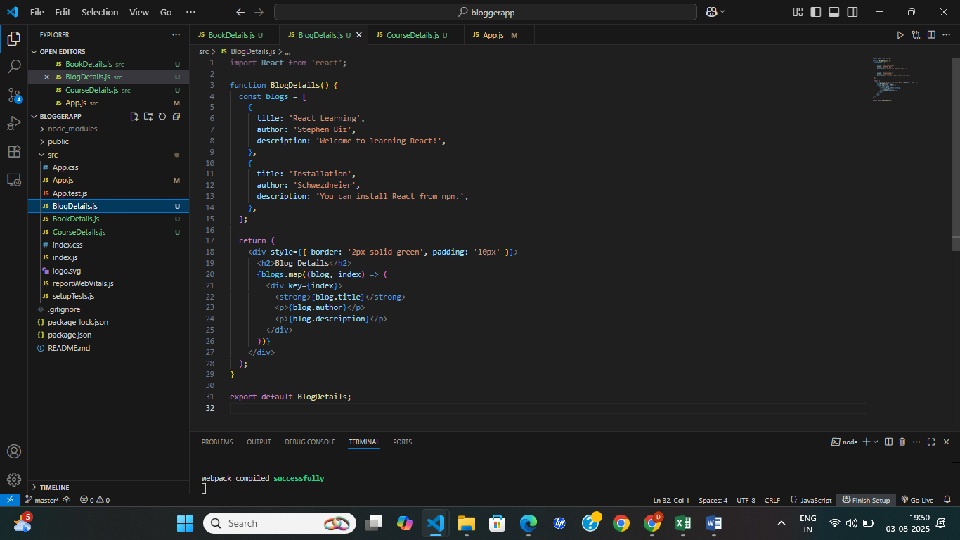

**CourseDetails.js**

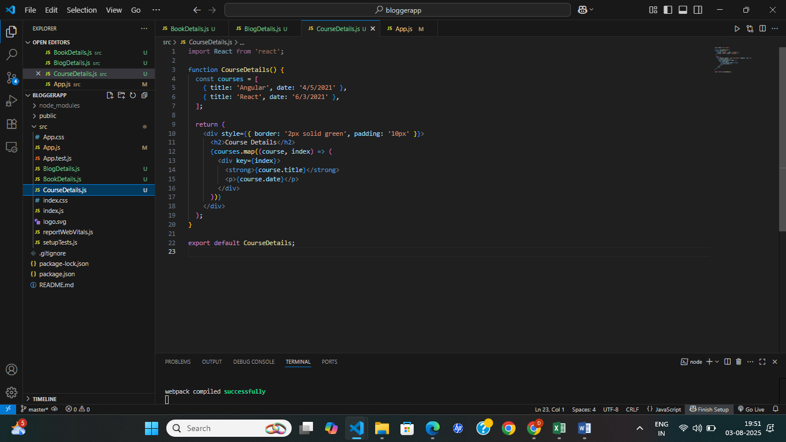

**App.js**

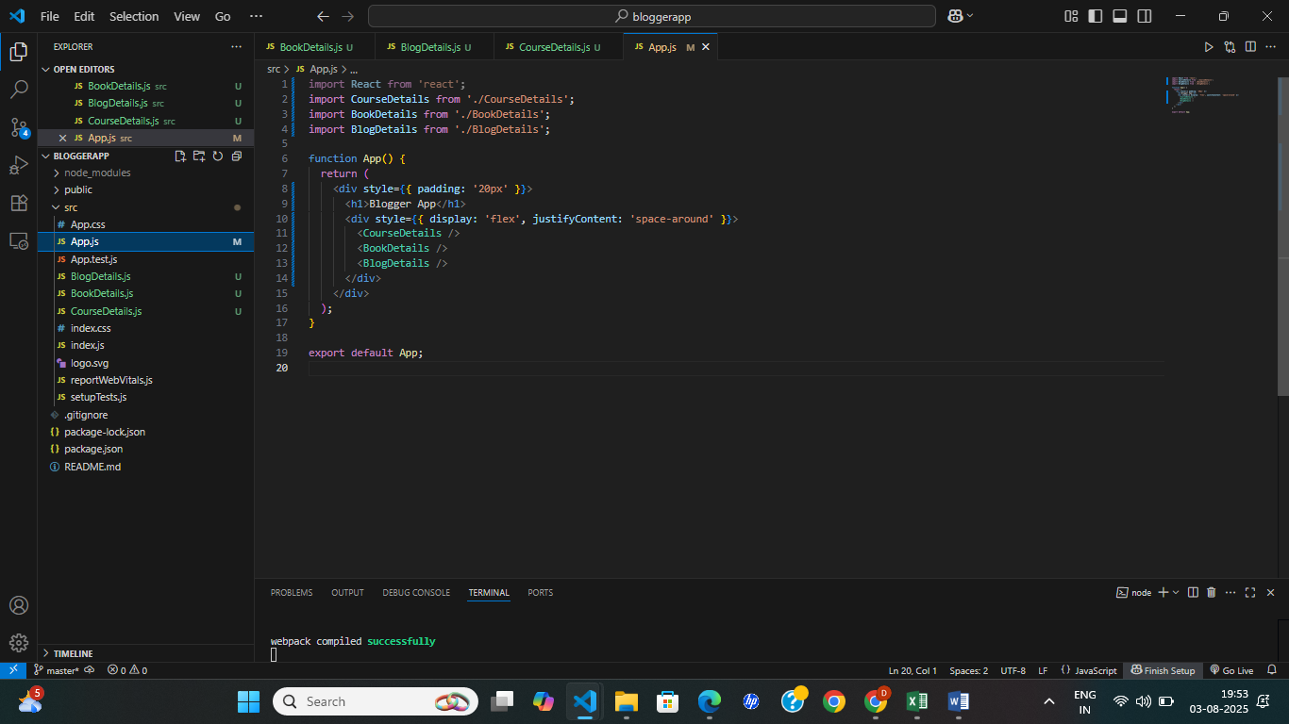

OUTPUT:

